ABHI Middle East
ACCELERATOR
Application Form: Company Name
Fostering strong relationships with healthcare organisations and hospital systems across the Middle East (ME), as well as a growing expert network on-hand to offer guidance and insight, the ABHI ME Accelerator is the ideal platform for companies looking to explore, scope and upscale their business in the Middle East.

To apply to join the 2025 ME Accelerator Programme, please complete the application form below, complete all sections fully as we will not be able to accept an incomplete form.

Disclaimer: The information collected in this form will remain confidential. We may share certain elements of this form with a select group of ME partners to validate your fit for the program. Your privacy is important to us, and we will ensure that your information is handled securely.

Please send the completed application form to MEAcclerator@abhi.org.uk

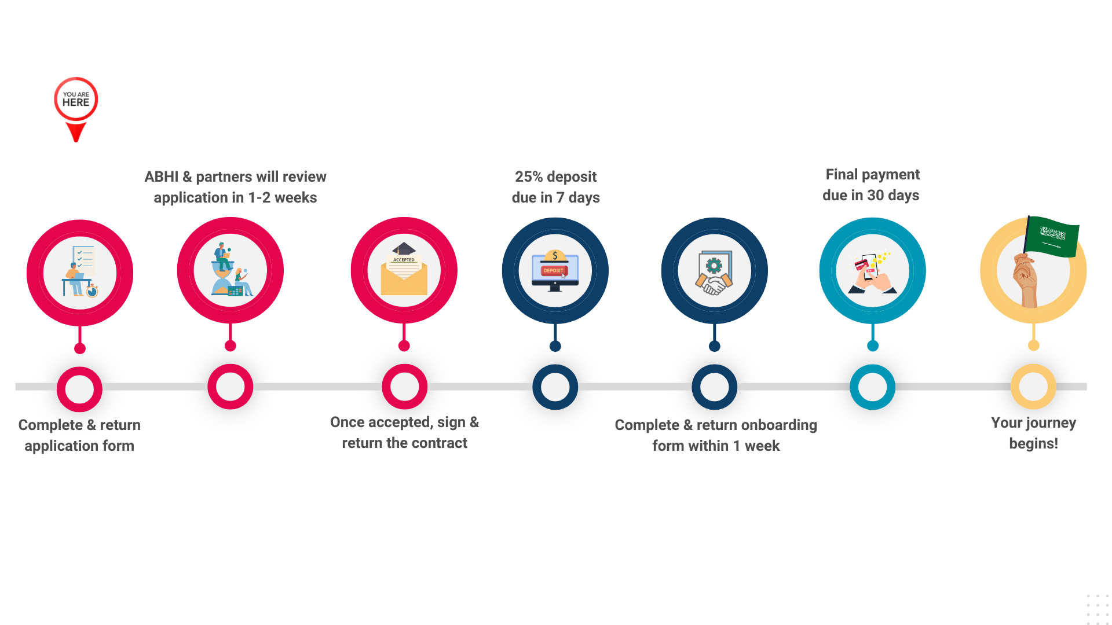

Section 1 – Contact Information
Please provide contact information for the two primary contacts who will be directly involved with the accelerator programme. Having these core contacts will allow us to facilitate engagement.

Primary Lead
Name
Job Title
Email
Phone Number
Secondary Lead
Name
Job Title
Email
Phone Number

Please provide contact information for the finance representative involved with the accelerator programme to support in efficient processing of financial updates and transactions.

Finance Lead
Name
Job Title
Email
Phone Number

Section 2 – Company Details
The following sections enable ABHI to gain insight into your organisation and evaluate its suitability for the programme.

Name of Company | Click or tap here to enter text.
Trading Name
Address of Company
Website
LinkedIn and/or Twitter
UK Company Registration Number
No. of Employees
Annual Turnover
How long has your company been trading?
Company Directors

Do you have a business registered in the Middle East? | ☐Yes ☐No
If selected yes, please fill out the following information
Company Name
Country Registration
Company Registration Number
No. of Employees

Section 3– Funding Information
If applicable, please provide the following information.

Sources of funding
How have you been funded? | ☐ Family Office  ☐ Angel Investor  ☐ Venture Capital  ☐ Private Equity  ☐ Grant Funding  ☐ Other, please specify:
Revenue generation
Are you currently generating revenue? | ☐ Yes  ☐ No
If yes, please specify how much
Investment plans and status
Are you looking to raise investment in the next 18 months? | ☐ Yes  ☐ No
If yes, how much are you looking to raise?
Details on your current investors

Section 4– Product Information

Product category | Choose an item.  Please describe if selected ‘other’:
Please clearly describe the problem your product/solution is addressing
Please provide a short description of your product/solution
Please clearly describe your distinct value proposition

Section 5– Product/Solution Background

Where was your product/solution developed? | Click or tap here to enter text.
Have pilot studies and/or clinical trials been conducted in the UK? | ☐ Yes  ☐ No  ☐ Planned  Where/with whom are/have those taking place:
Please select your active UK customers | ☐ NHS/public health sector  ☐ Private health sector  ☐ Academic or Research Institutions  ☐ Direct-to-consumer  ☐ Other, please specify:
Please select the main care setting of your product/solution | Choose an item.  If you selected multiple, please specify:

Section 6– Company Readiness
We understand there may be overlap between these descriptions; please select the option that best applies to you.

How best would you describe your readiness for the ME market? Please select one
☐ Exploratory Phase
We are seeking to understand and research the ME market, determine product market fit, identify customer base, identify key opinion leaders and partners, build a comprehensive go-to-the market strategy
☐ Market Making Phase
We are seeking to validate our go to market strategy, navigate regulatory pathways and reimbursement, generate evidence/data and pilot our solution in the ME
☐ Market Ready Phase
We have built a market entry strategy, have regulatory approval and are now ready to find our first partners and customers
☐ Scaling Phase
We have ME customers and are now wanting to build a sales pipeline

Section 7– ME Customer Profile

Please select the main customer groups you are targeting in the Middle East | ☐ Healthcare Providers (e.g., Doctors, Nurses)  ☐ Healthcare Facilities (e.g., Hospitals, Clinics)  ☐ Direct-to-consumer  ☐ Academic and Research Institutions  ☐ Insurance Companies  ☐ Industry (e.g., Med-Tech, Diagnostic, Digital Health, Pharma, Bio-Pharma Corporates)  ☐ Corporate Wellness Programmes  Please specify other:

Section 8 – Current Position in the ME Market

Are you currently selling your product/service in the ME market? | ☐ Yes  ☐ No  If yes, where are most of your customers i.e. country:
Do you have active pilots or clinical trials in the ME? | ☐ Yes  ☐ No  If yes, where/with whom are those taking place:
Who are your main competitors in the ME, and what differentiates your product from theirs?

Section 9 – What do you want to achieve by participating in the programme

What is your primary objective from your participation in the programme?
How will you measure the success of your participation in the programme?
What specific challenges are you looking to address through the programme?
What are your short-term and long-term goals for your company in the Middle East?

Thank you for completing the ME Accelerator Application form, please send the completed application form to MEAccelerator@abhi.org.uk



