Computerisation of Medical Systems
By: Svetlana Fathers, Medtec Europe Content Manager
25/10/15
Integration of information and communication technologies into medical systems, clinical studies and various health applications has grown significantly over the past several years, and the trend in computerising the healthcare system is gathering momentum.
As hospitals face many challenges to improve and provide safer and more effective solutions for patients, computerisation is a powerful tool that drives many initiatives and promotes medical innovation. Computers can significantly reduce costs and provide a better experience for both staff and patients. However, despite it obvious benefits and positive impact on healthcare in general, computerisation still poses a number of challenges, from failed IT projects to operator error, and has seen some criticism.
In this article we will review the advantages of computerisation, examine its applications and highlight the key issues associated with computerising medial system as well as provide some solutions.
Hospitals today are being redefined as they house a larger variety of computer-based medical equipment and smart connected medical devices. Not only Healthcare as a whole, but actual medical facilities are becoming more digitised with high-tech medical devices that are capable of managing data amongst many other things.
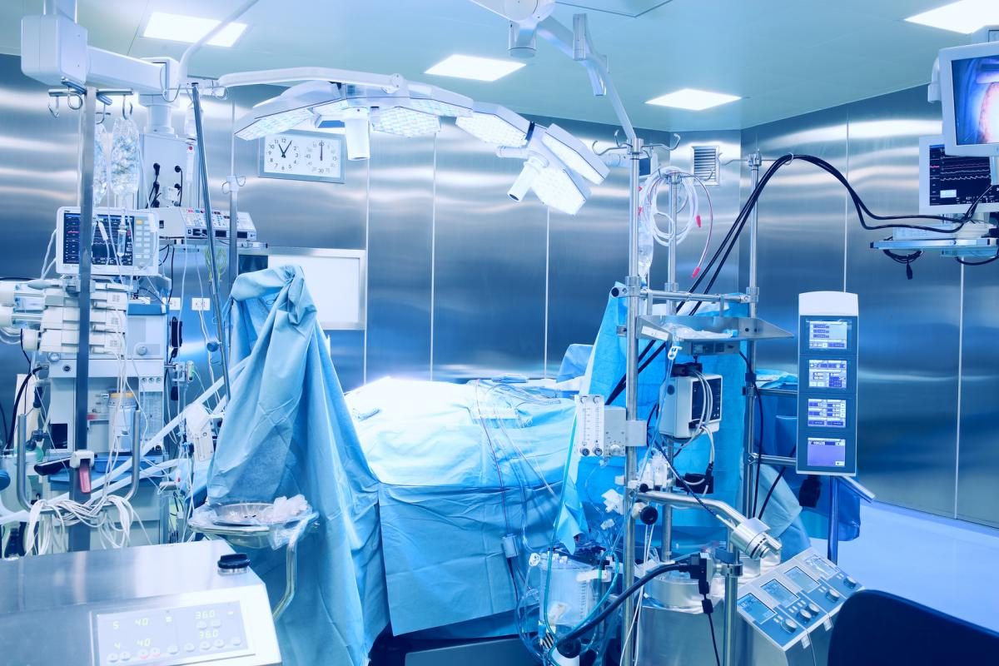
Medical equipment such as diagnostic equipment, laboratory/analytical equipment, drug dispensing carts, computerised physiotherapy, patient infotainment terminals, multi-parameter patient monitoring, endoscopy and Computers-on-Wheels (CoWs) all leverage PC-based architectures and feed data into the EMR, which acts as both a permanent repository for health information and a system that can be accessed instantly by doctors to assist with clinical decisions.
Today, more than ever, healthcare providers install more technology into hospital settings in order to contain costs, reduce complexity and increase the quality of healthcare.
Some good example of a computerised medical technology in a hospital setting can be Point-of-Care terminals, patient infotainment terminals, mobile clinical assistants, medical tablets, single board computers and diagnostic displays.
Computerisation has driven a lot of the medial innovations. It has enabled many notable advances in the development of digital health technologies. Perhaps the best example of a process computerisation has made possible is eHealth – a fairly recent healthcare practice supported by electronic processes and communication. It encompasses a wide range of services or systems that are at the edge of medicine/healthcare and information technology, including:
• Electronic health records: enabling the communication of patient data between different healthcare professionals
• Computerised Physician Order Entry: a means of requesting diagnostic tests and treatments electronically and receiving the results
• ePrescribing: access to prescribing options, printing prescriptions to patients and sometimes electronic transmission of prescriptions from doctors to pharmacists
• Clinical Decision Support: providing information electronically about protocols and standards for healthcare professionals to use in diagnosing and treating patients
• Telemedicine: physical and psychological diagnosis and treatments at a distance, including telemonitoring of patients functions
• Consumer health informatics: use of electronic resources on medical topics by healthy individuals or patients
• Health knowledge management: e.g. in an overview of latest medical journals, best practice guidelines or epidemiological tracking (examples include physician resources such as Medscape and MDLinx)
• Virtual healthcare teams: consisting of healthcare professionals who collaborate and share information on patients through digital equipment
• mHealth or m-Health: includes the use of mobile devices in collecting aggregate and patient level health data, providing healthcare information to practitioners, researchers, and patients, real-time monitoring of patient vitals, and direct provision of care (via mobile telemedicine)
• Medical research using Grids: powerful computing and data management capabilities to handle large amounts of heterogeneous data
• Healthcare Information Systems: also often refer to software solutions for appointment scheduling, patient data management, work schedule management and other administrative tasks surrounding health
(Source: https://en.wikipedia.org/wiki/EHealth)
An interesting by-product of eHealth and telemedicine that has recently emerged is Cybermedicine. Cybermedicine is enabled by the use of Internet in medical-related services such as consultations and prescriptions. An excellent example of Cybermedicine is a Cyber Doctor, a remote communication tool between a patient and a medical professional.
Technological innovation brought on by medial computerisation continues to impress. We now have a robot doctor that visit patients by roaming the hospital, guided by sensors and software that maps locations to avoid collisions.
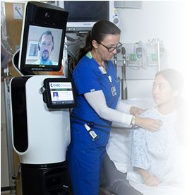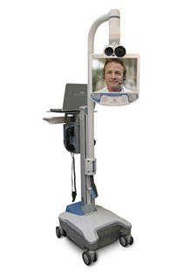
Figure 1
Courtesy of http://www.intouchhealth.com/
RP-VITA (Figure 1) is the first remote presence solution for patient care that combines autonomous navigation and mobility developed by iRobot with telemedicine technology from InTouch Health.
There are numerous other clinical and medical applications that have emerged with the introduction of computerisation into healthcare. It is worth noting some of the key clinical uses telehealth can offer, such as transmission of medical images and data for diagnosis or disease management and videoconferencing enabling instantaneous interaction between patient and healthcare provider. The latter is a classified as real-time mode of clinical telehealth. Other real-time examples enabled by videotelephony and Health information technology (HIT) are:
Tele-audiology | Telecardiology | Teledentistry
Telebehavioral Health | Telepsychiatry | Teleneurology
Telehomecare | Teleradiology | Telerehabilitation
Teleneuropsychology | Telepharmacy | Teletrauma care
Telesurgery (Remote surgery) | Teleradiology | Telepathology
Teledermatology | Teleophthalmology | Telenursing
There are some clear benefits computerisation of medical systems provides both for patients and hospital staff. Apart from its capability to significantly cut the overall healthcare costs, the trend can demonstrate a considerable reduction in hospitalisations, with the help of remote patient monitoring through mobile technology. This, in turn, reduces the need for outpatient visits and enables remote prescription verification and drug administration oversight, potentially significantly reducing the overall cost of medical care.
Computerisation can also play a positive role in the elimination of the transmission of infectious diseases between patients and medical staff by using various telehealth systems. Besides, it can help some patients suffering from a white coat syndrome, when a number of process can be performed outside of a clinical setting and in the comfort of their own home.
The Whole System Demonstrator (WSD) programme launched by the UK government in 2008 took a closer look at computerisation of healthcare systems as part of its telehealth trial that involved 3,030 people with one of three conditions (Diabetes, Chronic Heart Failure and COPD). The findings highlighted:
• 45% reduction in mortality rates
• 20% reduction in emergency admissions
• 15% reduction in A&E visits
• 14% reduction in elective admissions
• 14% reduction in bed days
• 8% reduction in tariff costs
Despite these apparent benefits, computerisation comes with its own challenges. The biggest concern surrounding this trend is privacy issue regarding patient records, most specifically the EPR (Electronic patient record), and confidentiality of the data.
Another concern is related to medical equipment becoming perforated with malware. Computerised hospital equipment is progressively more vulnerable to malware infections, which can be an obstruction to patient-monitoring equipment and other software systems. While no major accidents have been reported, the malware problem at hospitals remains a cause for concern.
Other important consideration is the cost of telecommunication and data management equipment and of technical training for medical personnel who will be using it.
Nonetheless, the strong potential computerisation demonstrates cannot be ignored. Computerised medical systems are capable of significantly improving healthcare and solve many problems currently encountered in clinical practice.
